**EDS THEORY ACTIVITY 1**

**NAME:** AARYA MADURWAR

**DIVISION:** CS5

**ROLL NO.:** CS5-28

**PRN:** 202401100106

**PROBLEM STATEMENT:**

1. Find the total number of emails

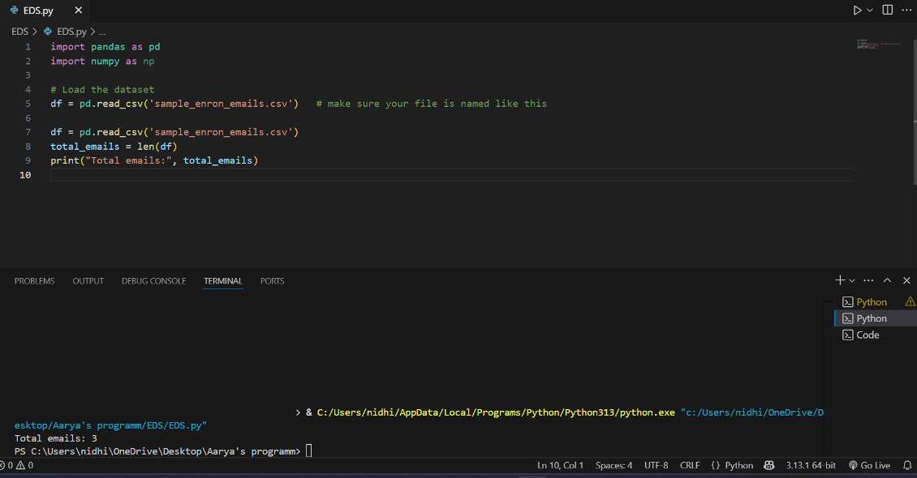

1. Find the number of unique senders.

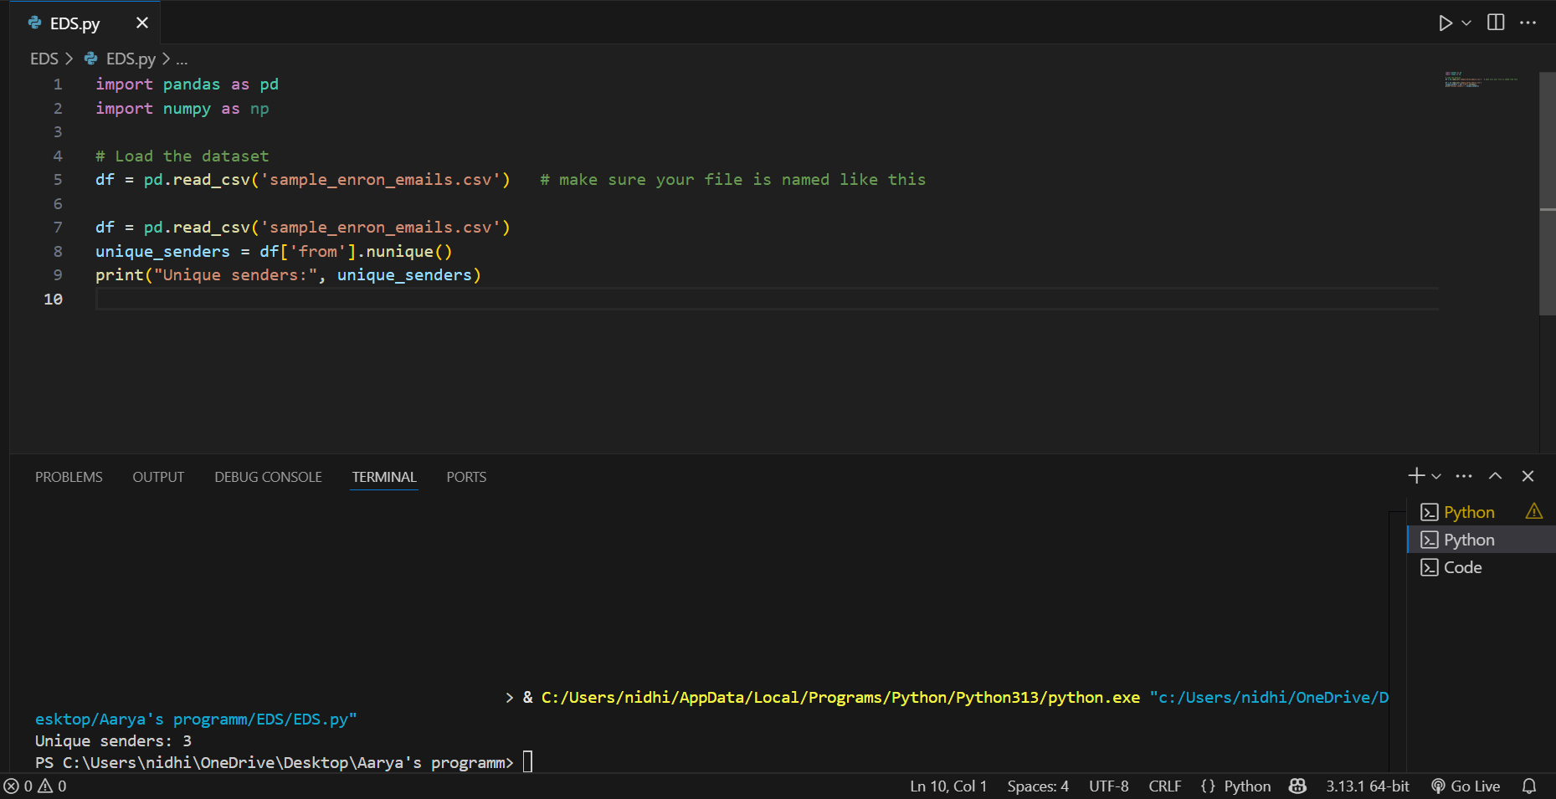

1. Find the top 5 most active senders.

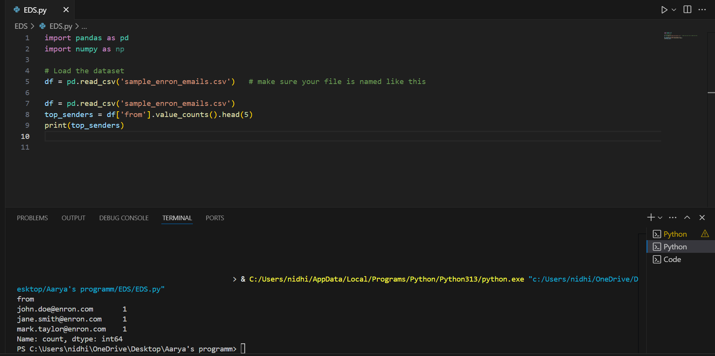

1. Find the number of emails sent to more than 1 recipient.

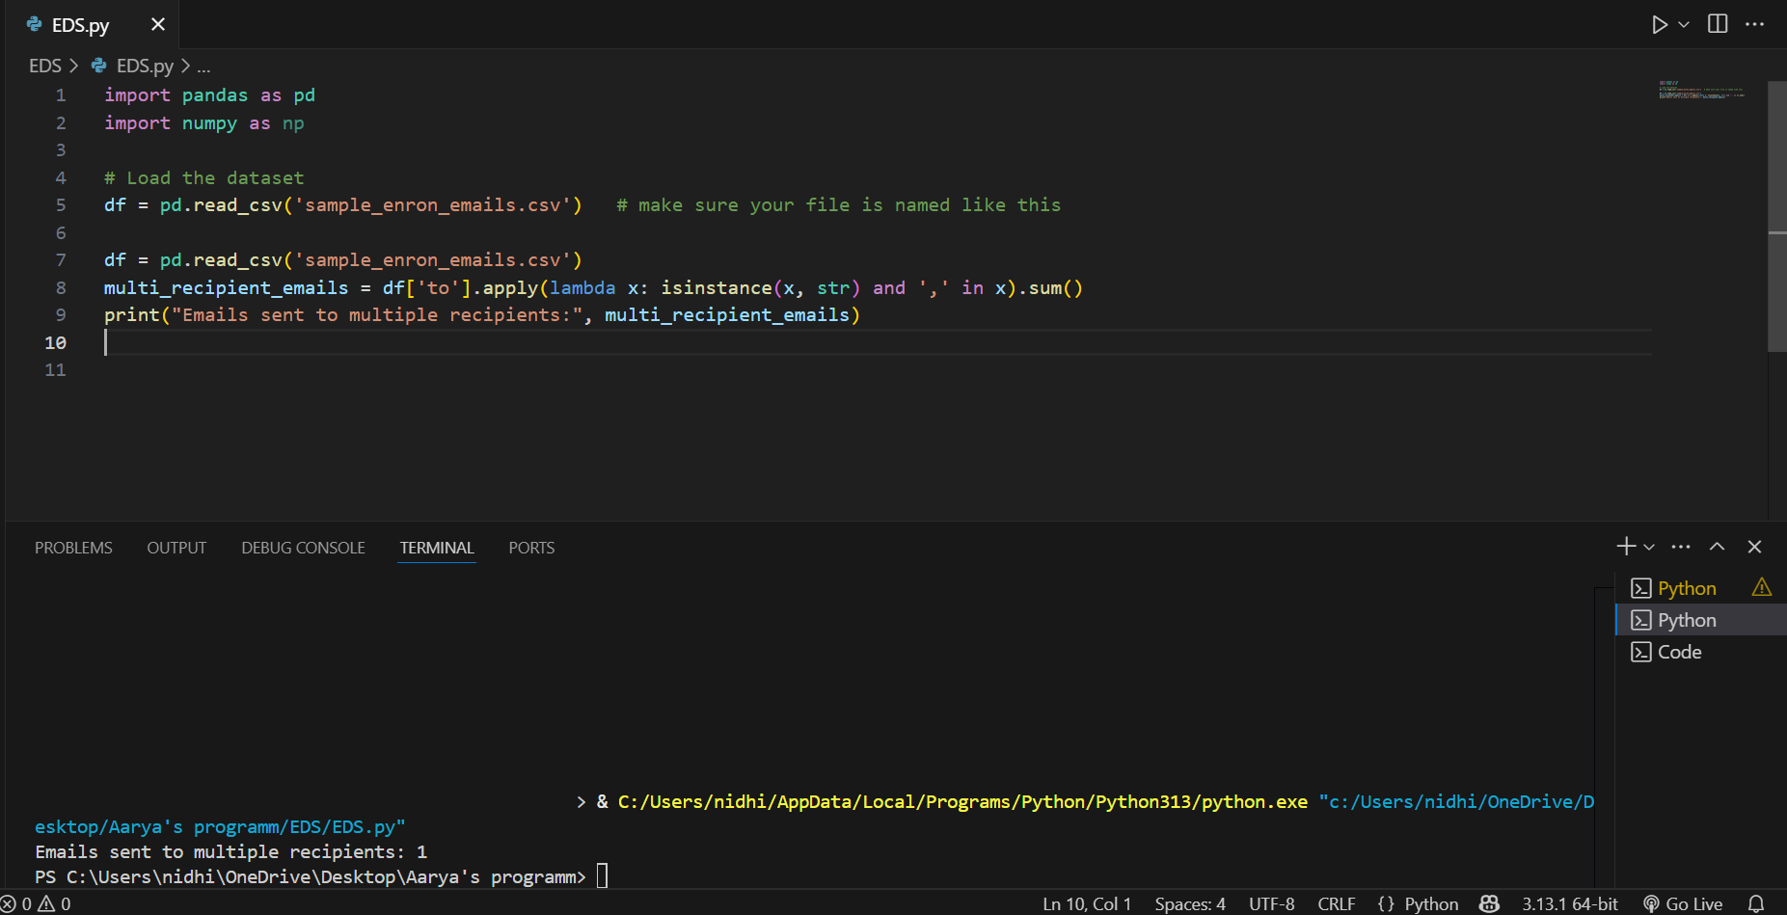

1. Find the most common recipient email address.

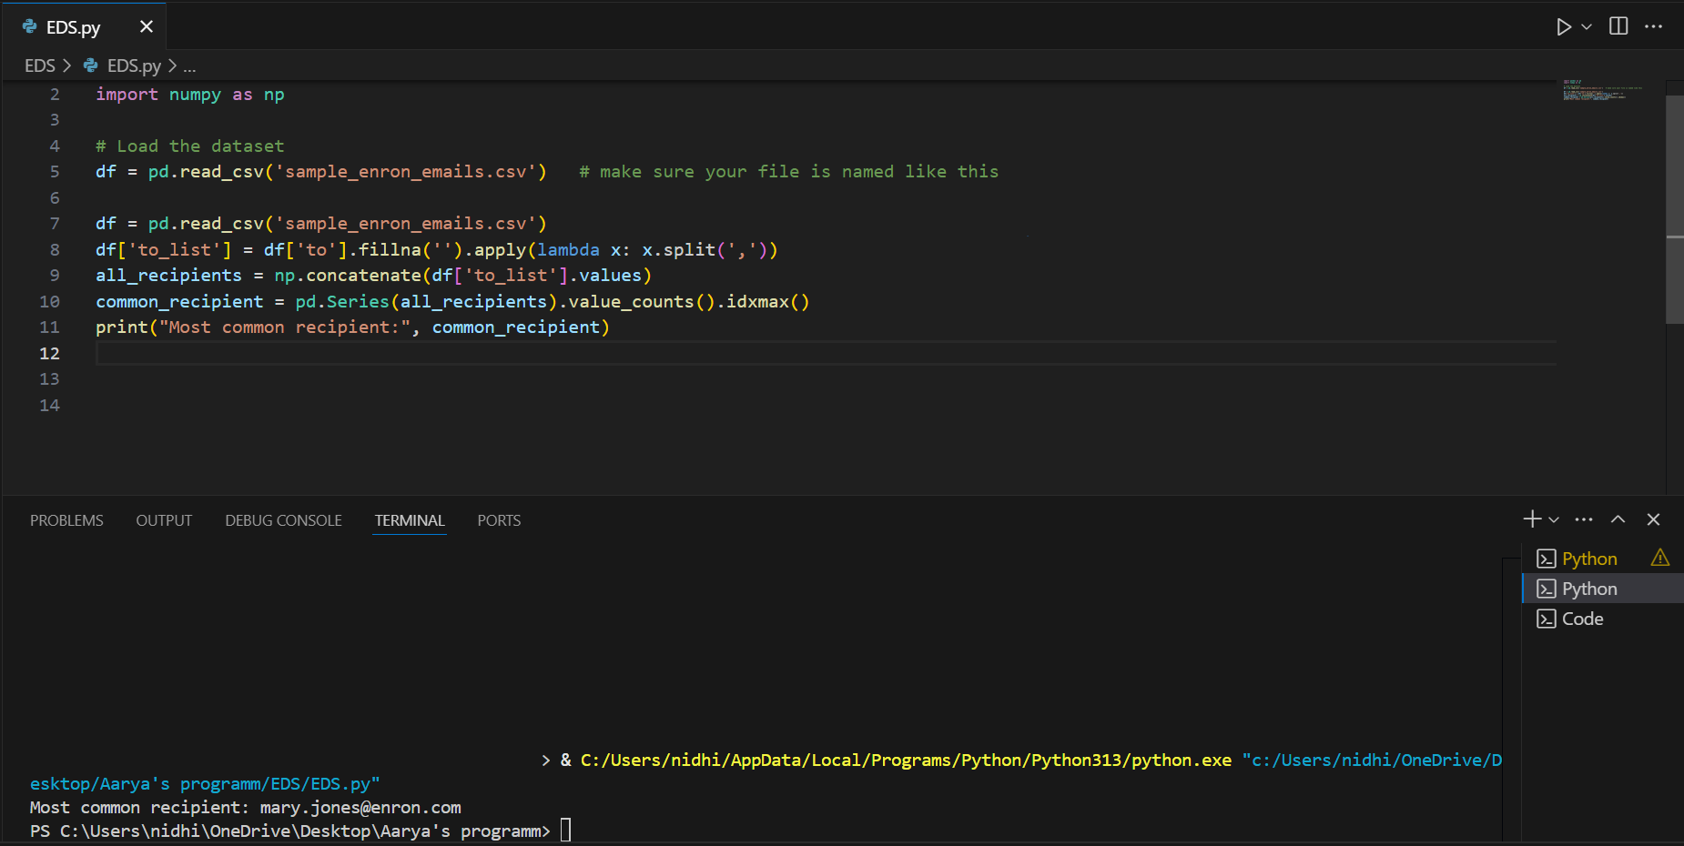

1. Find the number of emails that have "confidential" in the subject.

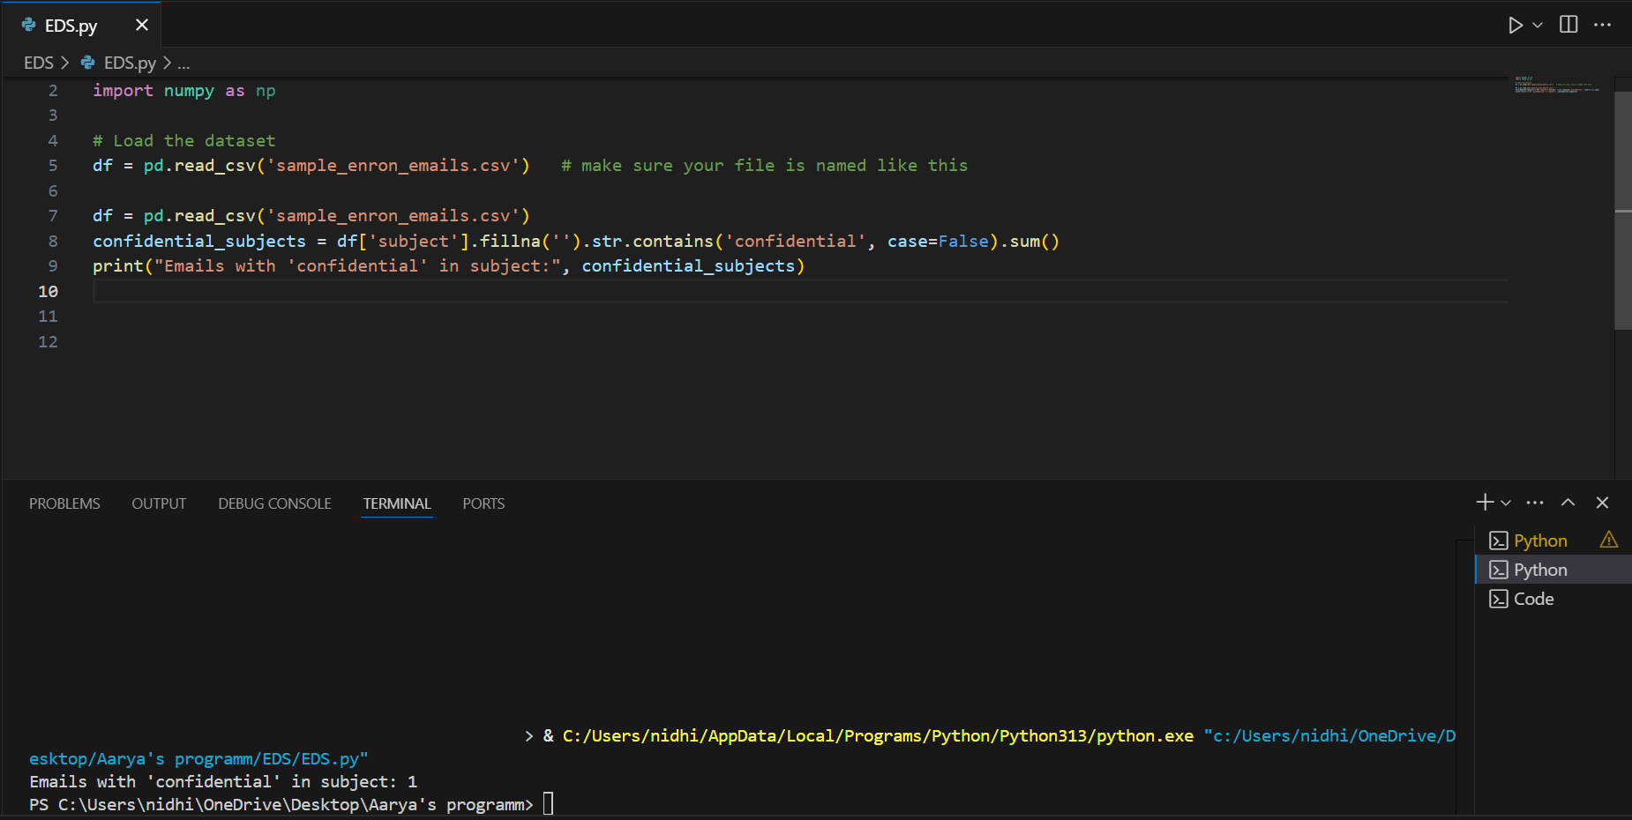

1. Find emails sent during weekends.

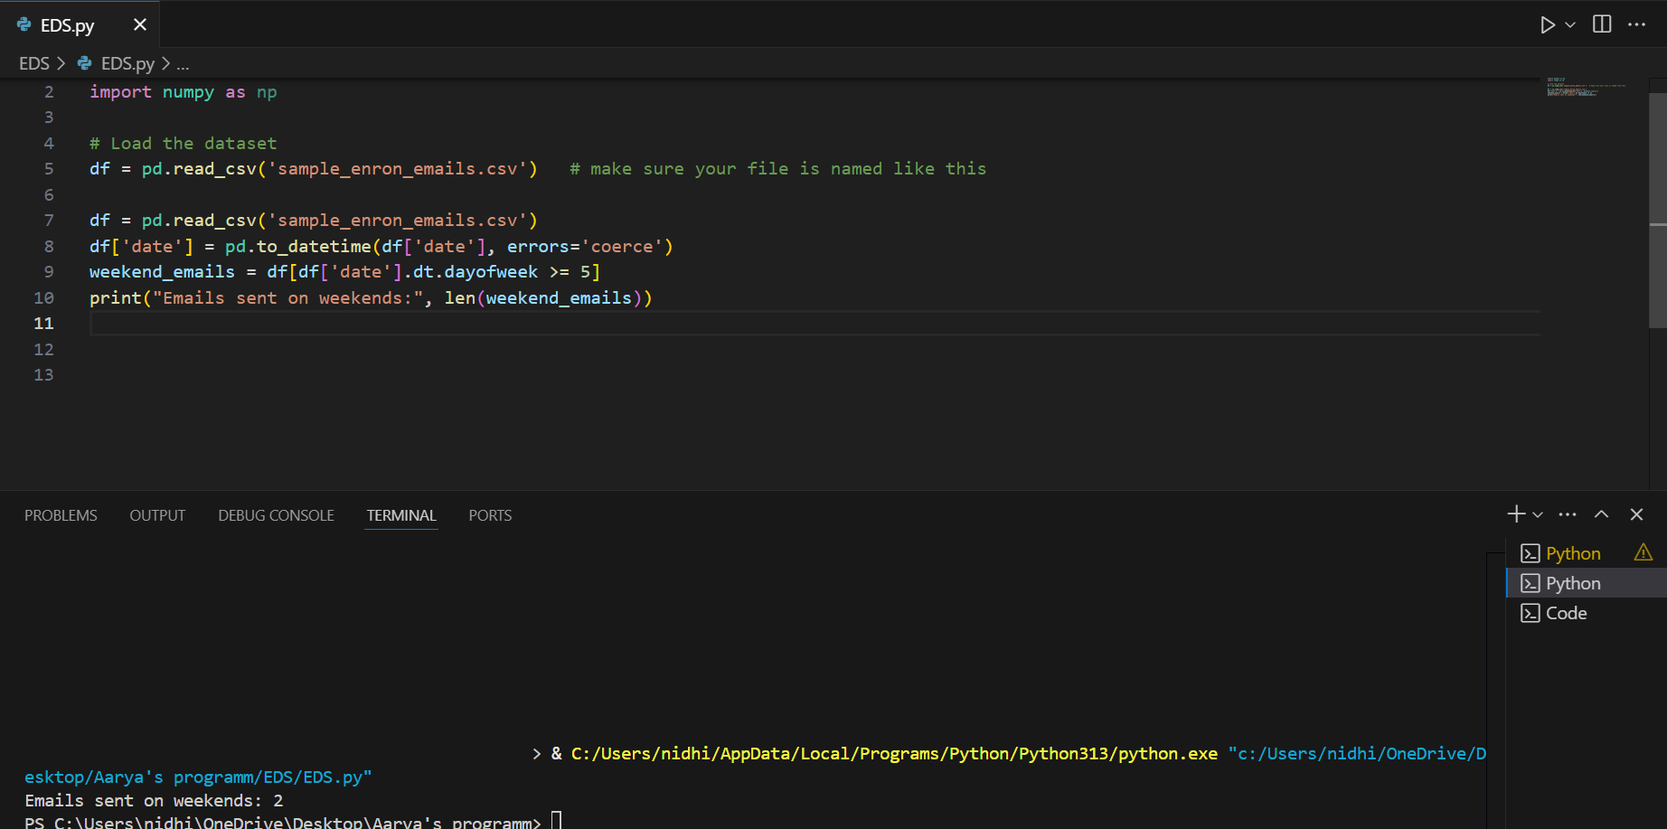

1. Find the month with the highest number of emails sent.

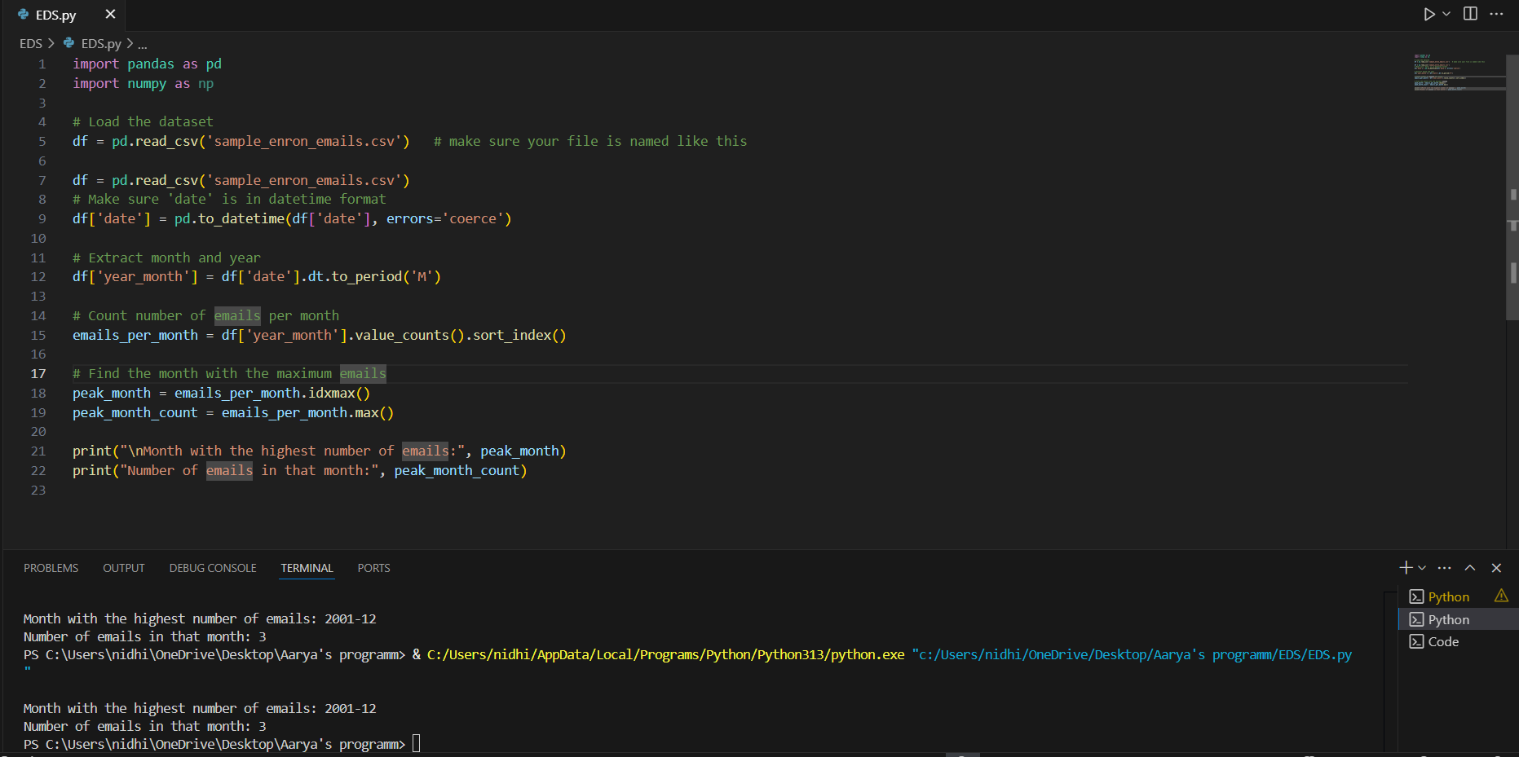

1. Find emails with empty bodies.

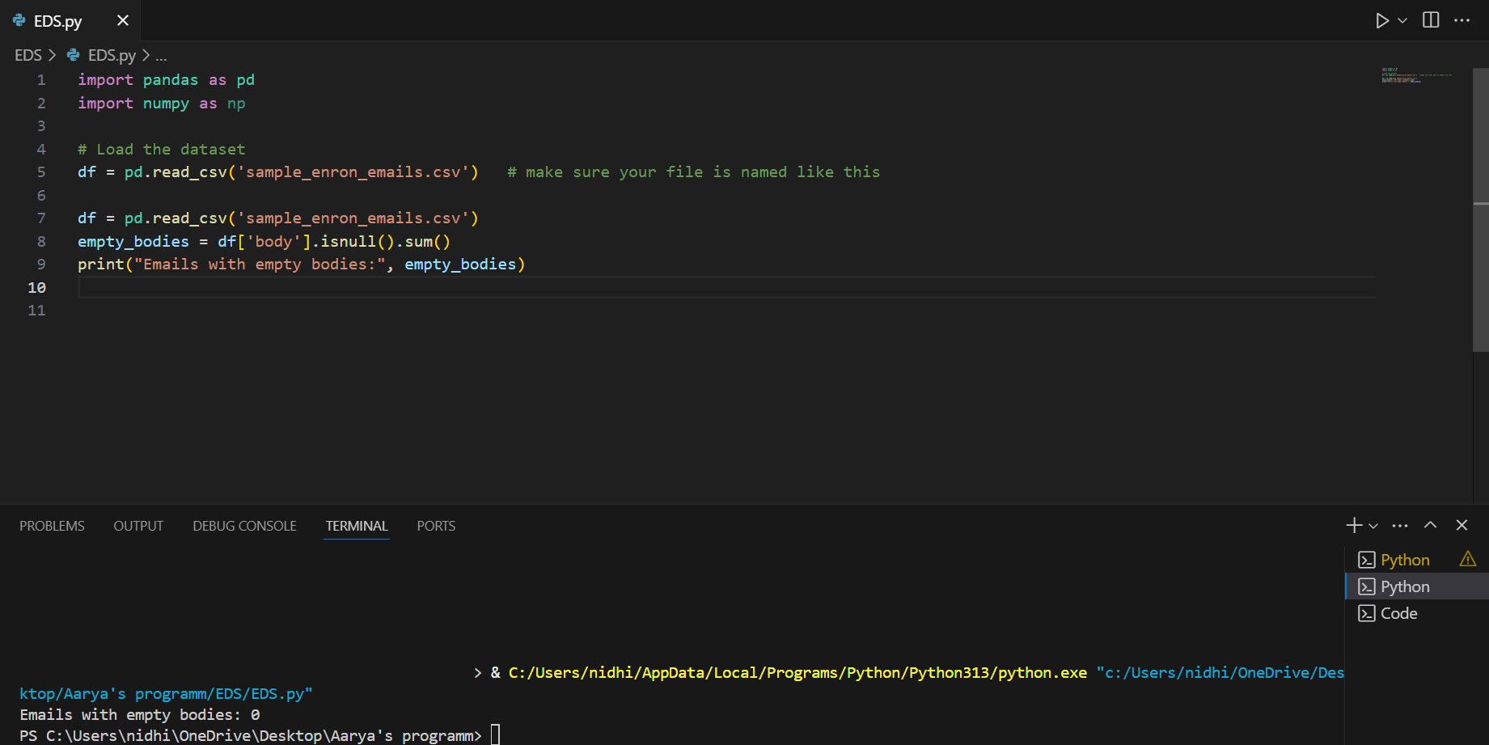

1. Find the top 5 folders with the most emails.

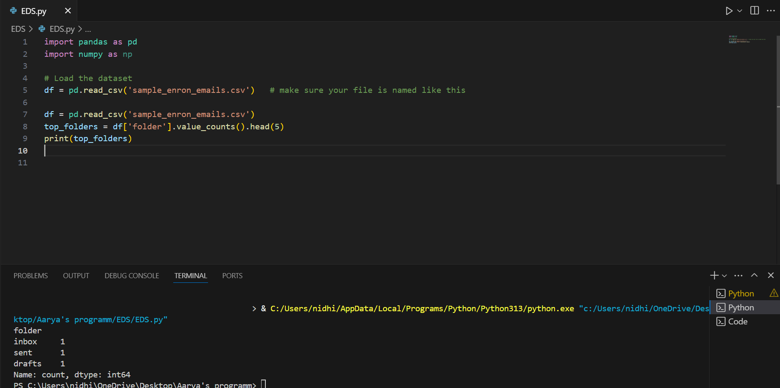

1. Find the percentage of emails with CC recipients.

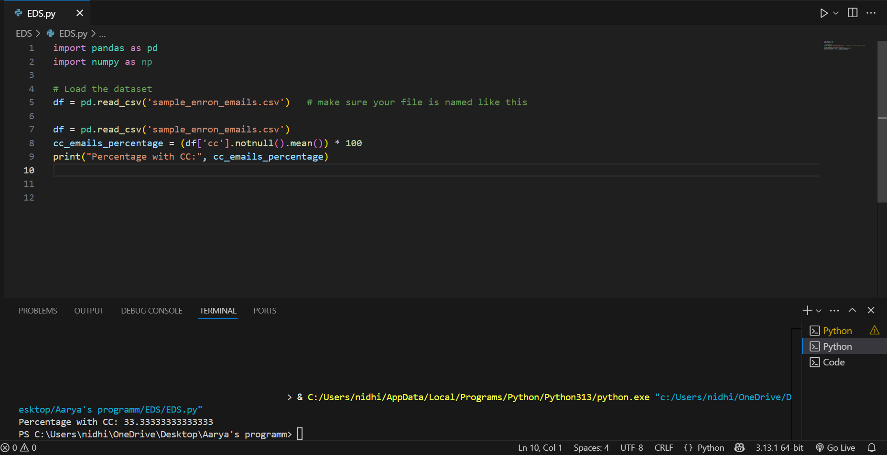

1. Find the most common day of the week when emails were sent.

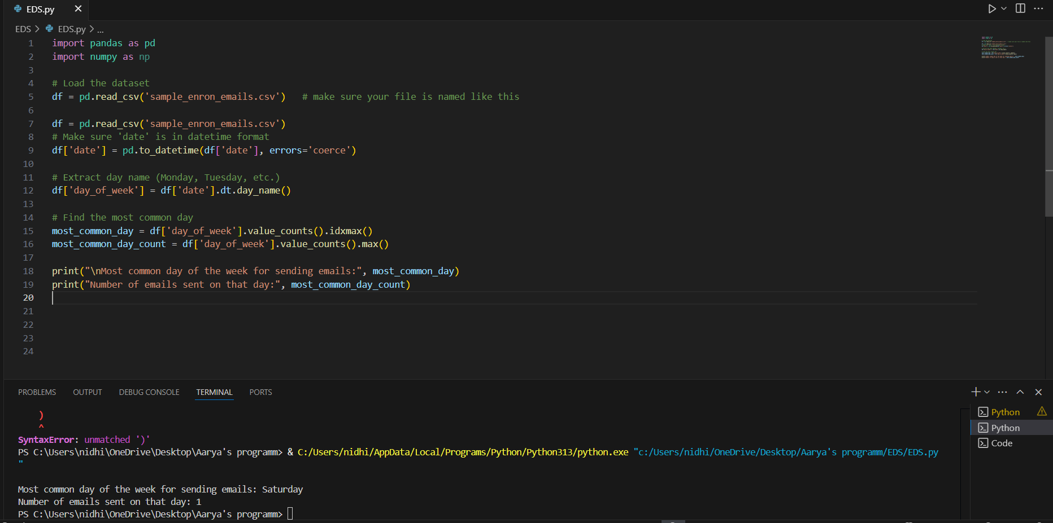

1. Find the earliest and latest email dates.

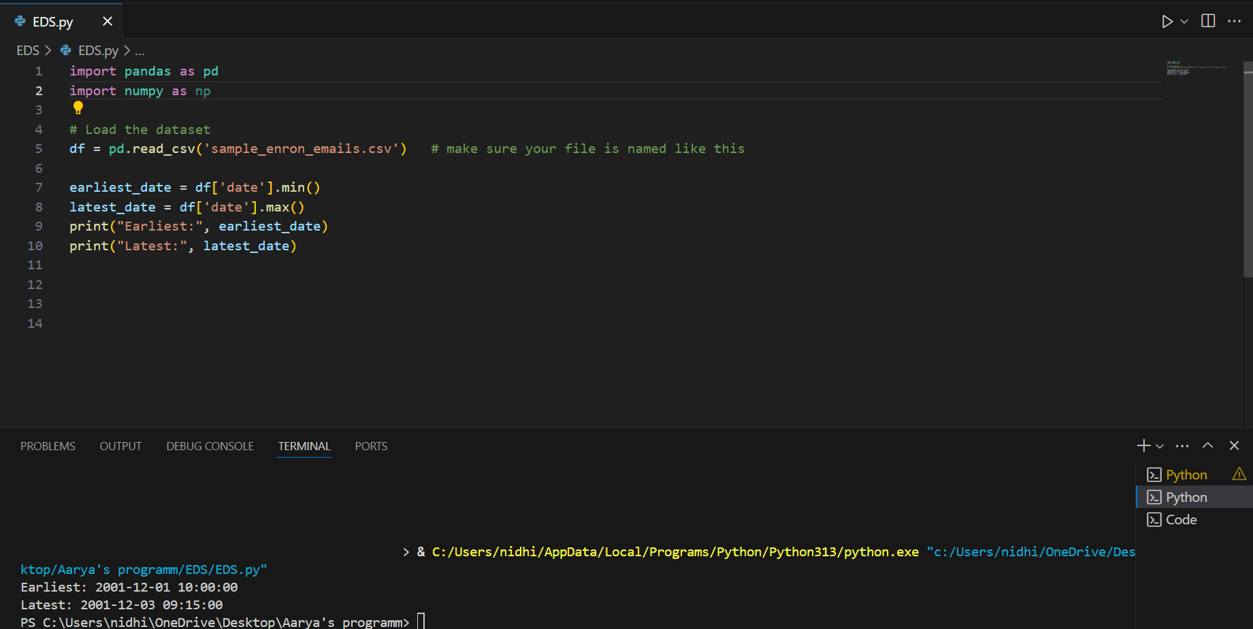

1. Find the number of emails with subjects longer than 100 characters.

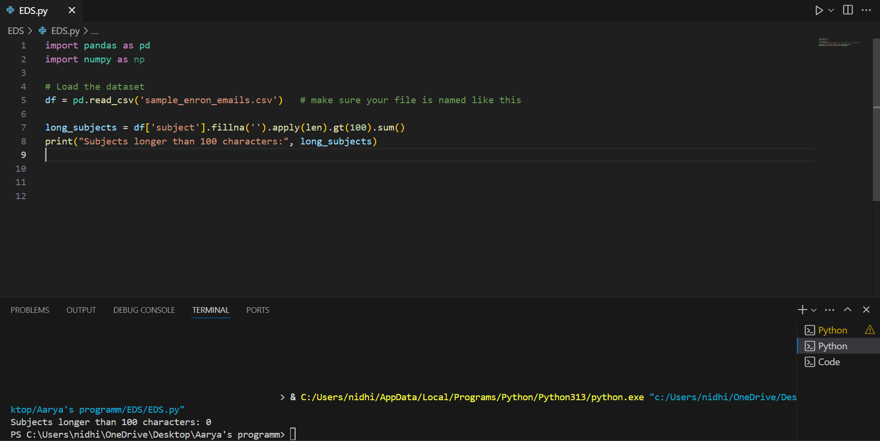

1. Find the most common domain among sender addresses.

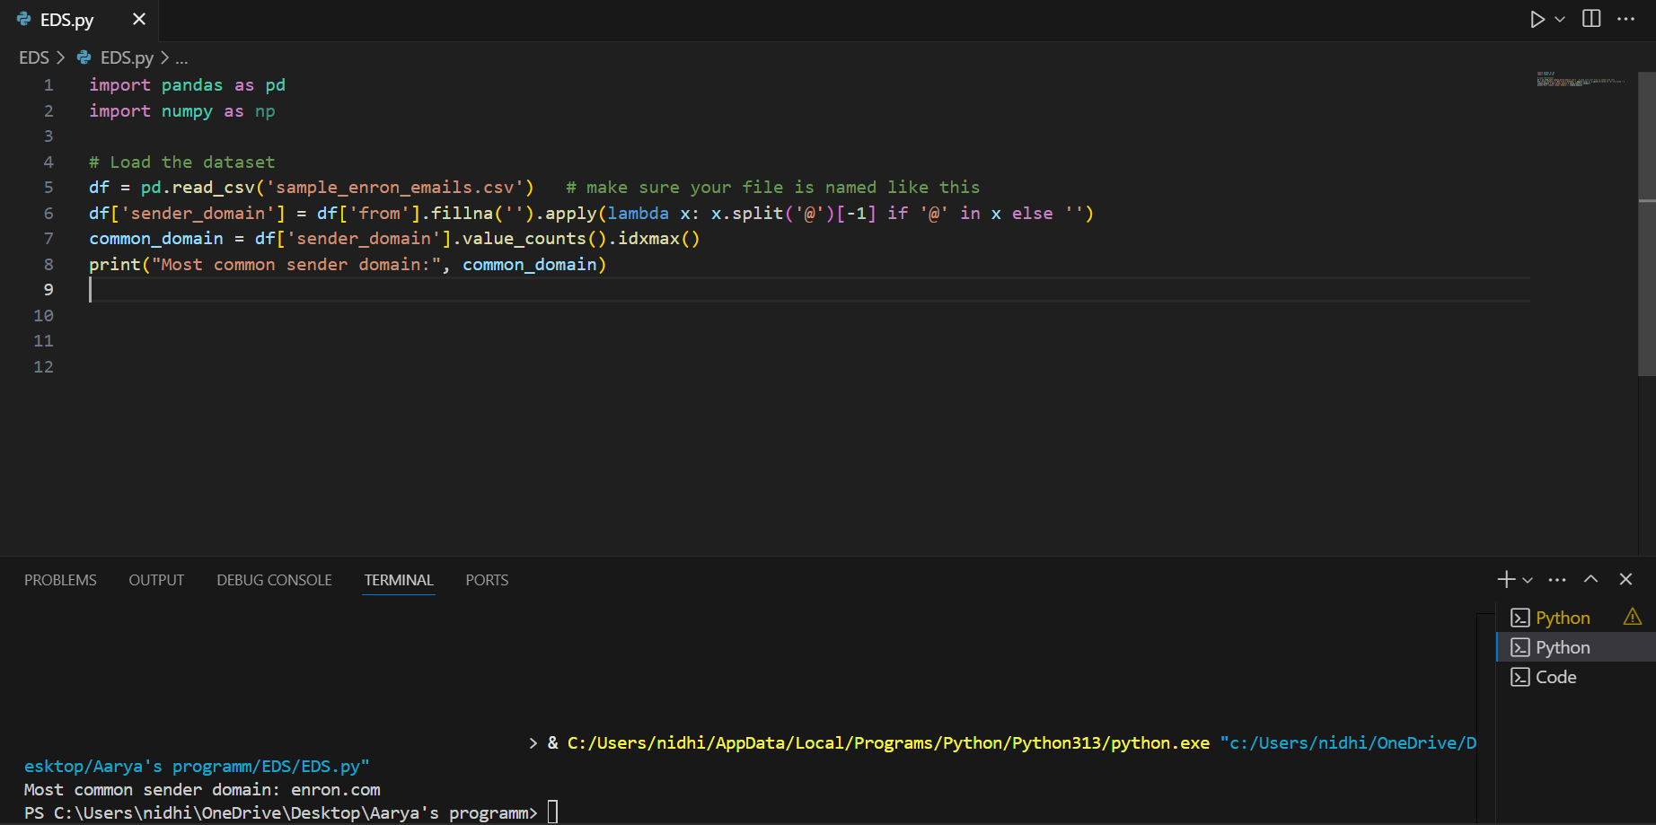

1. Find the ratio of emails that have attachments. (Assuming "file" column hints at attachment)

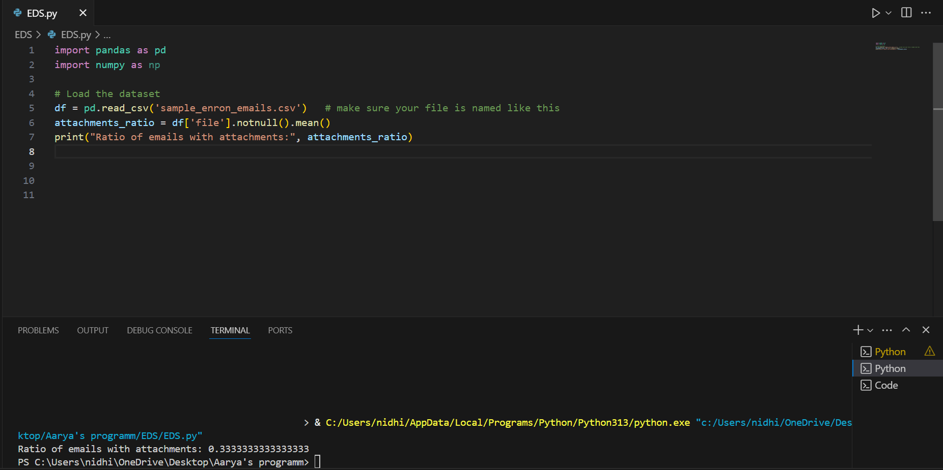

1. Find top 5 most common words in email bodies.

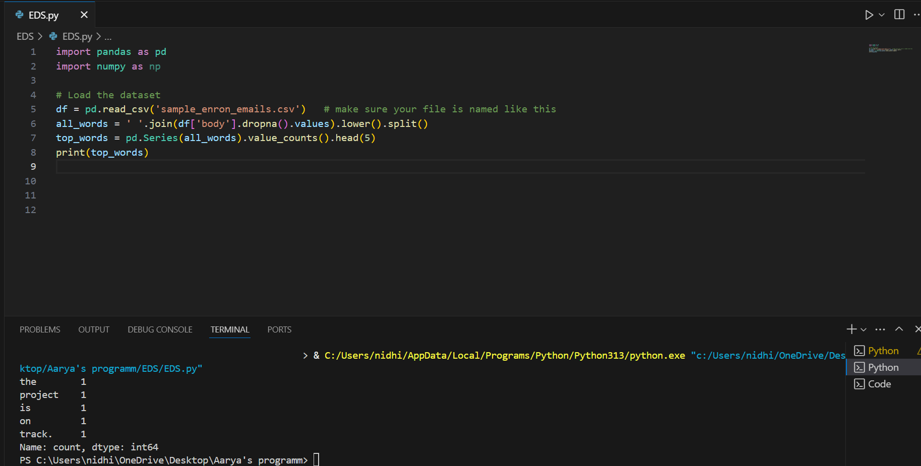

1. Find the sender who sent the longest email body (in terms of number of characters).

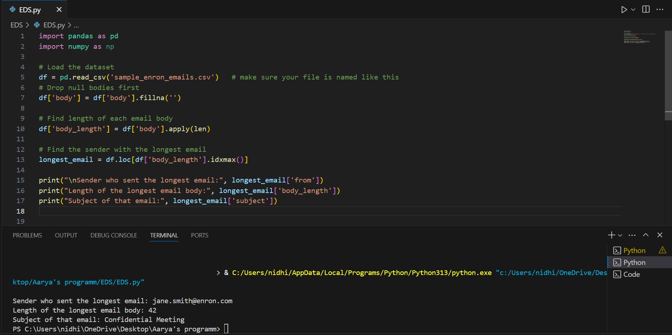

1. Find the average body length of emails.

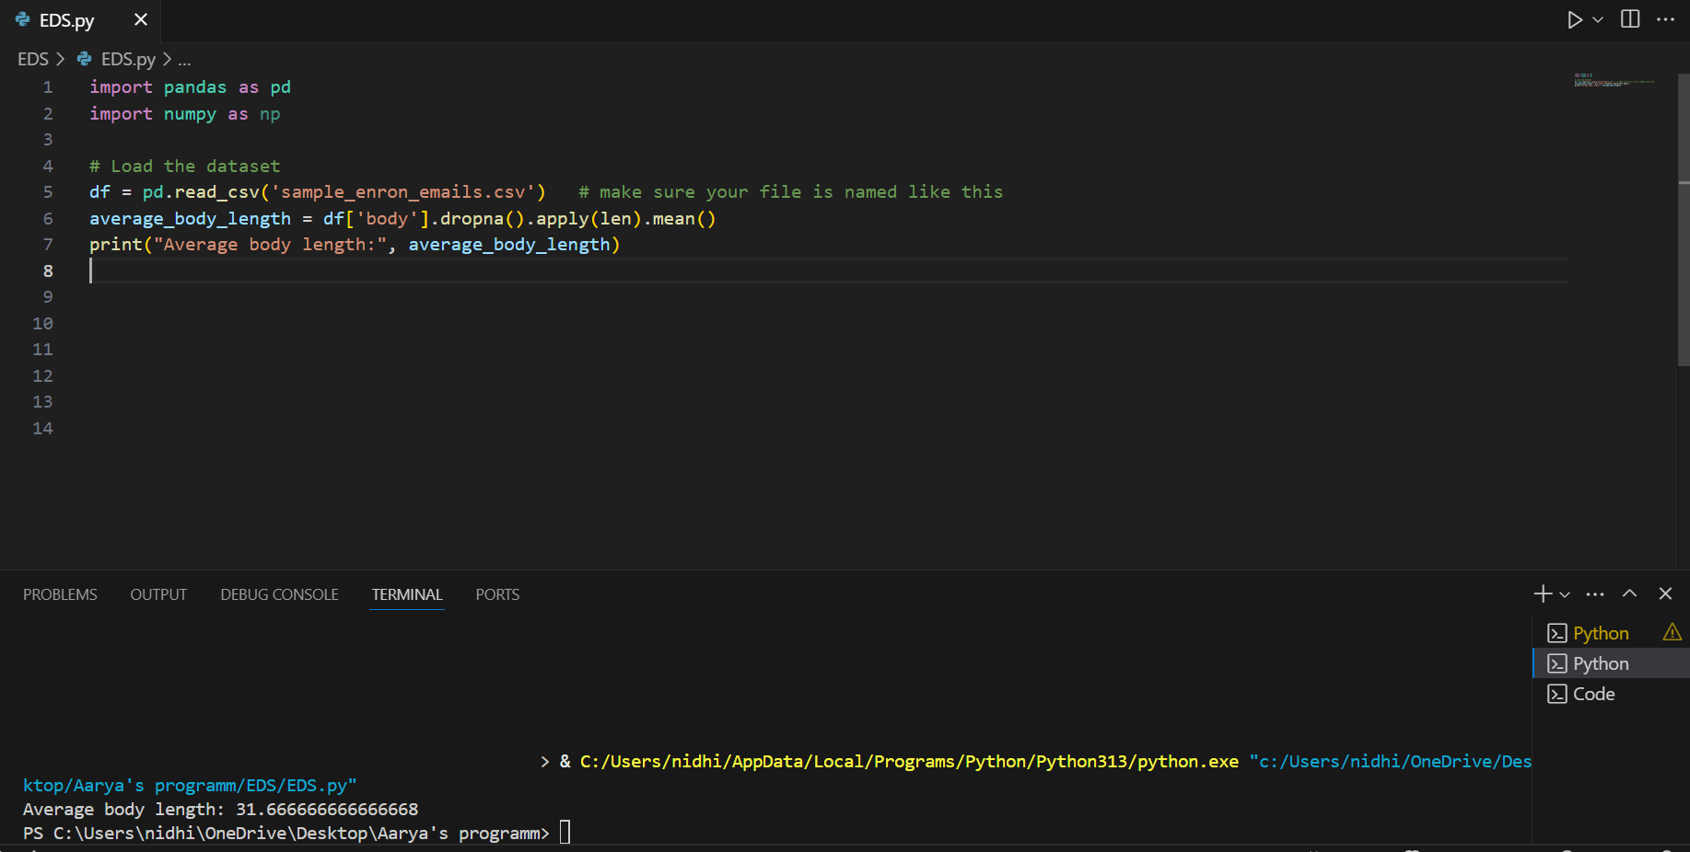

20. Find the number of emails without a subject.

